Senior Dining Menu-Bayfield County Home Delivered Meals December 2025

Meal Reservation Line – (715) 373-3396

MONDAY | TUESDAY | WEDNESDAY | THURSDAY | FRIDAY
1 | 2 | 3 | 4 | 5
Broiled Fish  Lemon Garlic Sauce  Coleslaw  Roasted Potatoes  Tropical Fruit  Whole Wheat Bread | Salisbury Steak  Mashed Potatoes  & Brown Gravy  Mixed Veggies  Whole Wheat Bread | Broccoli Cheese Soup  Egg Salad Croissant  Cottage Cheese  Peaches | Spaghetti  & Meat Sauce  Asian Slaw  Banana | NO MEAL
8 | 9 | 10 | 11 | 12
Beef Stroganoff  Egg Noodles  Succotash  Fruit Dessert | Tater Tot Hotdish  Three Bean Salad  Dream Fruit Salad  Whole Wheat Bread | Scallop Potatoes  & Ham  Green Beans  Cole Slaw  Pudding  Whole Wheat Bread | Meat Loaf  Glazed Carrots  Mash Potatoes  & Gravy  Pears  Whole Wheat Bread | NO MEAL
15 | 16 | 17 | 18 | 19
Shepard’s Pie  Apple Sauce  Three Bean Salad  Whole Wheat Bread | Cheeseburger  Lettuce, Tomato  Onion  Baked Beans  Jello & Fruit  Whole Wheat Bun | Meat Balls  Mash Potatoes  Mixed Veggies  Peaches  Whole Wheat Bread | Ham Dinner Sweet Potatoes  Monte Carlo Blend  Mandarin Oranges  Whole Wheat Bread  Dessert | NO MEAL
22 | 23 | 24 | 25 | 26
Mexican Skillet  Cole Slaw  Pears | Chicken Cordon Bleu  Rice Pilaf  Mixed Veggie  Brussel Sprouts  Peaches | NO MEAL | NO MEAL | NO MEAL
29 | 30 | 31 | 1
Fish Sandwich  Roasted Potatoes  Coleslaw  Pears  Dessert | Chili & Cornbread  Pineapple | NO MEAL | NO MEAL

NOTE: Menus are subject to change without notice.

Word Search: Diet and Nutrition
wordmint.com

X | T | Y | R | N | T | Z | D | N | U | T | R | I | T | I | O | N | M
W | F | R | A | Y | F | F | V | E | C | O | E | N | Z | Y | M | E | E
S | A | I | B | L | G | H | C | H | F | P | T | R | H | H | S | W | T
Y | T | B | S | A | N | T | I | O | X | I | D | E | N | T | Z | F | A
N | S | O | O | W | O | C | C | U | R | I | C | J | G | G | D | R | B
T | O | F | R | Y | G | G | D | N | U | T | R | I | E | N | T | S | O
H | L | L | P | Z | D | I | M | M | U | N | E | L | E | M | M | N | L
E | U | A | T | H | T | H | I | A | M | I | N | E | N | N | C | L | I
S | B | V | I | A | W | O | J | B | I | O | T | I | N | L | C | S | S
I | L | I | O | X | W | E | L | L | N | E | S | S | O | C | I | Y | M
S | E | N | N | P | O | S | U | P | P | L | E | M | E | N | T | S | Q
M | J | D | I | G | E | S | T | I | O | N | I | A | C | I | N | V | E

Words

NUTRIENTS ANTIOXIDANT SUPPLEMENTS NUTRITION WELLNESS

IMMUNE DEFICIENCY METABOLISM ABSORBTION DIGESTION

SYNTHESIS FAT-SOLUBLE COENZYME PROTEIN NIACIN

THYMINE RIBOFLAVIN RETINOL PYRIDOXINE

December 2025 TOPIC: Supplements
Article courtesy of www.courier-journal.com

Three Things to Know about Dietary Supplements
Are Supplements Worth the Money Spent?  That depends on who you ask. When it comes to supplements, there is no end to the controversy. Since supplements are natural, research findings cannot be patented. | 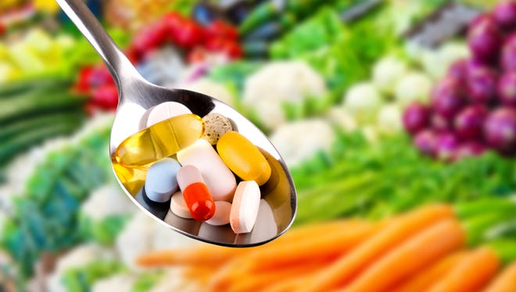
In an effort to police the quality of supplements, some nonprofit organizations have stepped up and are very helpful. For example, the United States Pharmacopeial Convention examines the strength and quality of dietary supplements and verifies contents. Large reputable supplement companies with their reputations at stake depend on the USP stamp of approval. So, it’s a good idea when purchasing supplements to look for USP verification on the label.

Pros to taking dietary supplements
Although you can get all the vitamins and minerals you need from a good diet, taking a supplement can — just in case — help fill in gaps. Despite the lack of large-scale sophisticated research, there is supporting evidence pf the positivity of many supplements. There is also a vast array of botanicals and herbs like echinacea believed to bolster immune health, and turmeric, a spice that acts as an anti-inflammatory.

What are the potential dangers of taking dietary supplements?
Large amounts of some vitamins that are fat-soluble (A, D, E, and K), can accumulate in your body fat. This can lead to toxicity when taken in large doses, especially for Vitamins A and D. Several minerals also are fat-soluble and should not be taken in excess. Especially important to doctors is the potential for adverse side effects that can interfere with prescription medications. In addition, taking some supplements prior to surgery could complicate things like blood clotting, etc. That’s why your doctor asks what supplements you take and may discourage you from doing so.
Source: www.courier-journal.com/story/life/wellness/health/2022/03/03/pros-vs-cons-of-taking-dietary-supplements/

December 2025 TOPIC: Dietary Supplements
Article courtesy of National Institute of Health

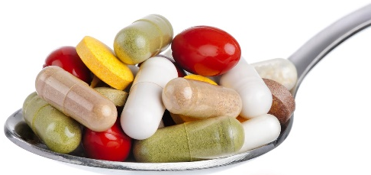 | Did you know….  - 70% of older Americans take at least one multivitamin or supplement daily.  - Vitamin C, vitamin E, and beta-carotene (a form of vitamin A) act as antioxidants. They prevent cells from being damaged by oxygen.  - Vitamin A is important for normal vision and immune function.  - Vitamin D is needed for bone health.  - Vitamin K is important for blood clotting.
Benefits of Dietary Supplements
Dietary supplements are intended to add to or supplement the diet and are different from conventional food. Dietary supplements can help you improve or maintain your overall health, and supplements can also help you meet your daily requirements of essential nutrients.

Risks
While the benefits of some supplements are well established, other supplements need more study. Also, keep in mind that supplements should not take the place of the variety of foods that are important for a healthy diet. Before buying or taking a dietary supplement, talk with a health care professional—such as your doctor, nurse, registered dietician, or pharmacist—about the benefits and risks.

Many supplements contain ingredients that can have strong effects in the body. Additionally, some supplements can interact with medications, interfere with lab tests, or have dangerous effects during surgery. Your health care professional can help you decide what supplement, if any, is right for you.

December 2025 Quick & Easy
Author: www.joyfoodsunshine.com

Pan Roasted Brussels Sprouts with Bacon
This Roasted Brussel Sprouts with Bacon recipe will convert even the most unlikely person into a sprouts lover. Crispy sprouts, salty bacon and sweet & tangy honey mustard come together in an irresistible side dish sure to impress. This Brussel sprouts and bacon recipe is low-carb and gluten-free, made with 8 ingredients in less than 30 minutes!

Ingredients  4 strips thick-cut bacon  2 tablespoons butter  1 pound Brussels sprouts, halved  1/2 large onion, chopped  Salt and freshly ground black pepper | 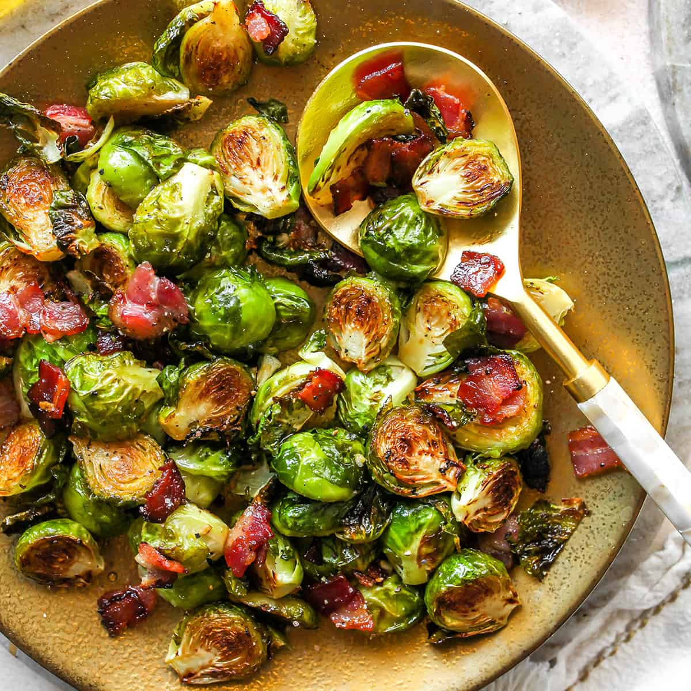
Instructions
- Cook bacon in a large skillet over medium-high heat until crispy.
- Remove to a paper towel-lined plate, then roughly chop.
- In same pan with bacon fat, melt butter over high heat.
- Add onions and Brussels Sprouts and cook, stirring occasionally, until sprouts are golden brown, 8 to 10 minutes.
- Season with salt and pepper, to taste, and toss bacon back into pan.
Serve immediately

Notes
Prep: 10 minutes Makes 4 to 6 servings
Cook: 15 minutes

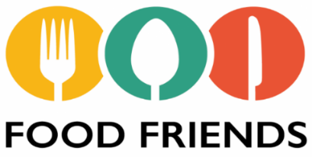
MENU
DECEMBER
2025

SENIOR DINING
More than a meal!



Meal Site Location Information To reserve your meal, call 715-373-3396

Barnes Town Hall  3360 County Hwy. N  Barnes, WI 54873 | Meal Days: Thursdays  Reservation required? Yes  Call by 9:00 a.m. the day before. | Site Opens: 11:30 a.m.  Meal Served: 12:00 noon
Bell Town Hall  22620 Ash Street  Cornucopia, WI 54827 | Meal Days: Tuesdays  Reservation required? Yes  Call by Monday at 8:30 a.m. | Site Opens: 11:30 a.m.  Meal Served: 12:00 noon
Cable United Church of Christ  13445 County Hwy. M  Cable, WI 54821 | Meal Days: 1st & 3rd Mondays of the month  Reservation required? Yes  Call by Thursday at 12:00 noon | Site Opens: 12:00 noon  Meal Served: 12:30 p.m.
Iron River Community Center  8275 E. Mill Street  Iron River, WI 54847 | Meal Days: 2nd & 4th Thurs. of the month  Reservation required? Yes  Call by Monday at noon | Site Opens: 11:30 a.m.  Meal Served: 12:00 noon
First Lutheran Church  83105 Washington Avenue  Port Wing, WI 54865 | Meal Days: Wednesdays  Reservation required? Yes  Call by Tuesday at 8:30 a.m. | Site Opens: 11:30 a.m.  Meal Served: 12:00 noon
Time Out Restaurant  4 Bayfield Street  Washburn, WI 54891 | Meal Days: Wednesdays  Reservation required? No  *Please be respectful of the restaurant and do not arrive earlier than 1:00 p.m. | Seating Opens: 1:00 PM*  Meal Served: 1:30 – 2:00 p.m.  Site Closes: 3:00 p.m.
St. Louis School  713 Washington Avenue  Washburn, WI 54891 | Meal Days: Fridays  Reservation required? Yes  Call by 3:00 p.m. Wednesday | Site Opens: 11:30 a.m.  Meal Served: 12:00 noon

Be sure to include your name, phone number, meal site location and date you are making the reservation, and how many people you are making reservations for.

Suggested contribution amount is $3.00 - $5.00 per meal. All contributions are used to fund the program.

K:\Aging and Disabilities\Elder Nutrition Program\Menus\Current\2025 Congregate\12-2025 menu.docx

