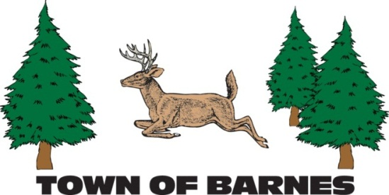
M E E T I N G N O T I C E
SPECIAL TOWN MEETINGS
Tuesday, November 18, 2025
6:00 p.m. at the Barnes Town Hall

ANNUAL PUBLIC BUDGET HEARING
followed by
SPECIAL TOWN ELECTORS MEETING
to vote on the 2025 total town tax levy to be collected in 2026

REGULAR MONTHLY TOWN BOARD MEETING
will immediately follow the budget meeting
The Agenda will be posted and also available on the Town Web Site: www.townofbarneswi.gov

Submitted by: Kari Hufnagle, Clerk-Treasurer
715-795-2782 clerk@townofbarneswi.gov

