.

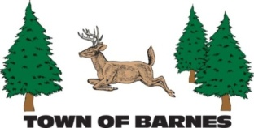

MINUTES OF THE TOWN OF BARNES ROADS AND RIGHT OF WAY COMMITTEE
May 6, 2025

Members present were Doug Westerberg, Mark Holm, Jack Gribble, Jeff Jordheim, Jim Frint
Meeting called to order at 6:40 pm, quorum established by roll call
Motion to approve minutes of 4/6/2025 passed (Gribble/Westerberg), no changes
There was no public comment.

Minutes posting
RROW minutes for 2025 are posted to the website through April.

Roads rating system
At least 120 township roads have been posted to Barnes road rating list, evaluated according to a point system based on five measurements of road condition, and then ranked by total points for each road. Committee wishes to recognize Jack Gribble for onsite observation and scoring, in addition to Doug Westerberg for spreadsheet sorting.
This system is intended to be used as a guide to assist committee and highway department in making future impartial determination of which roads need to be prioritized for work.

Barnstormers
Committee values the dialogue which has taken place with Barnstormers snowmobile club
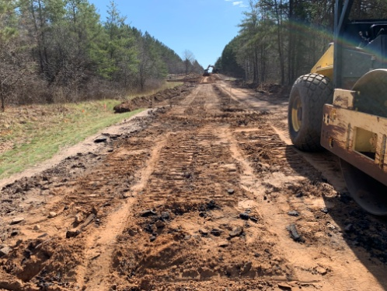
and is in possession of revised MOU dated 4/1/025. Committee and township anticipate continuing support of snowmobile hobbyists and the benefits they bring to local merchants and businesses.

Ellison/Moore intersect
Work has begun by Olson Brothers Construction of Brule to lower road grade and improve sightlines east of the intersection. Gradient of Ellison has long been a hazard to both auto and snowmobile traffic. We note this represents ongoing commitment of the highway department and township to safe travel in our community.

River Road bridge
Cedar Corp has done initial evaluation and survey work on this bridge, which was closed to through traffic in 2024 due to deterioration which made it a hazard to traffic, especially heavy vehicles. It was noted that even turtles have contributed to ongoing structural problems.
The committee, in crafting a workable policy for this bridge, discussed multiple hard topics including cost of replacing, prevailing emergency services, condition of poor roadway running south from the bridge, and travel convenience to the community.

Adjourn
Motion to adjourn (Frint/Westerbarg) passed unanimously, meeting adjourned 7:35;m

Respectfully submitted, Mark Holm, reorder

Next meeting Tuesday, May 6, 2025, 6:30pm, township grage

