Senior Dining Menu – Greater Bayfield County January 2025

Meal Reservation Line – (715) 373-3396

MONDAY | TUESDAY | WEDNESDAY | THURSDAY | FRIDAY
 |  | 1 | 2 | 3
 |  | NO MEAL | Chicken Fajita  Refried Beans  Flour Tortilla  Canned Pears | NO MEAL
6 | 7 | 8 | 9 | 10
Beef Shepard’s Pie  California Blend  Vegetables  Pears  Whole Wheat Roll | Brown Sugar  Glazed Ham  Peas & Carrots  Baked Beans  Fresh Fruit  Whole Wheat Bread | Spaghetti  and Meatballs  Lettuce Salad  Tomato Wedges  Sliced Cucumber  Garlic Bread  Canned Peaches  Ranch | Lemon Baked Chicken  Mashed Potatoes  Chicken Gravy  Pickled Beets  Fresh Fruit  Whole Wheat Roll | NO MEAL
13 | 14 | 15 | 16 | 17
Beef Stew  Mashed Potatoes  Biscuit  Pineapple | Egg Salad  Four Bean Salad  Lettuce & Tomato  Peaches  Slider Bun | Garlic Herb Pork Loin  Steamed Broccoli  Baked Potato  Sour Cream  Canned Pears | Braised Beef Tips  Mashed Potatoes  Steamed Green Beans  Chocolate  Black Bean Cake | NO MEAL
20 | 21 | 22 | 23 | 24
Baked Chicken  with Thyme Sauce  Mashed Potatoes  Steamed Carrots  Whole Wheat Roll  Fresh Fruit | Salisbury Steak  Mashed Potatoes  Brown Gravy  Peas & Carrots  Pineapple  Whole Wheat Roll | Kielbasa Sausage  Sauerkraut  Baked Beans  Fresh Fruit  Hot Dog Bun | Lasagna  Italian Vegetables  Peach Halves  Garlic Bread | NO MEAL
27 | 28 | 29 | 30 | 31
Beef Chili  Spinach  Fresh Fruit  Saltines | Tomato Basil Soup  Parmesan Roasted Potatoes  Fresh Fruit  Whole Wheat  Dinner Roll | Sweet & Sour  Meatballs  Brown Rice  Tomato & Cucumber Salad  Pineapple  Asian Blend Vegetables | Chicken Broccoli Alfredo  Italian Vegetables  Fresh Fruit  Garlic Bread | NO MEAL

NOTE: Menus are subject to change without notice.

Word Search: Citrus Fruits
sciencenotes.org
Words:  Bergamot orange  Cara cara  Clementine  Etrog  Greek citron  Kinnow  Kumquat  Leech lime  Lemon  Mandarin  Moroccan citron  Orange  Pomelo  Satsuma  Sudachi  Tangelo  Tangerine  Ugli fruit  Yuzu  Hyuganatsu  Corsican citron  Grapefruit  Kobosu | 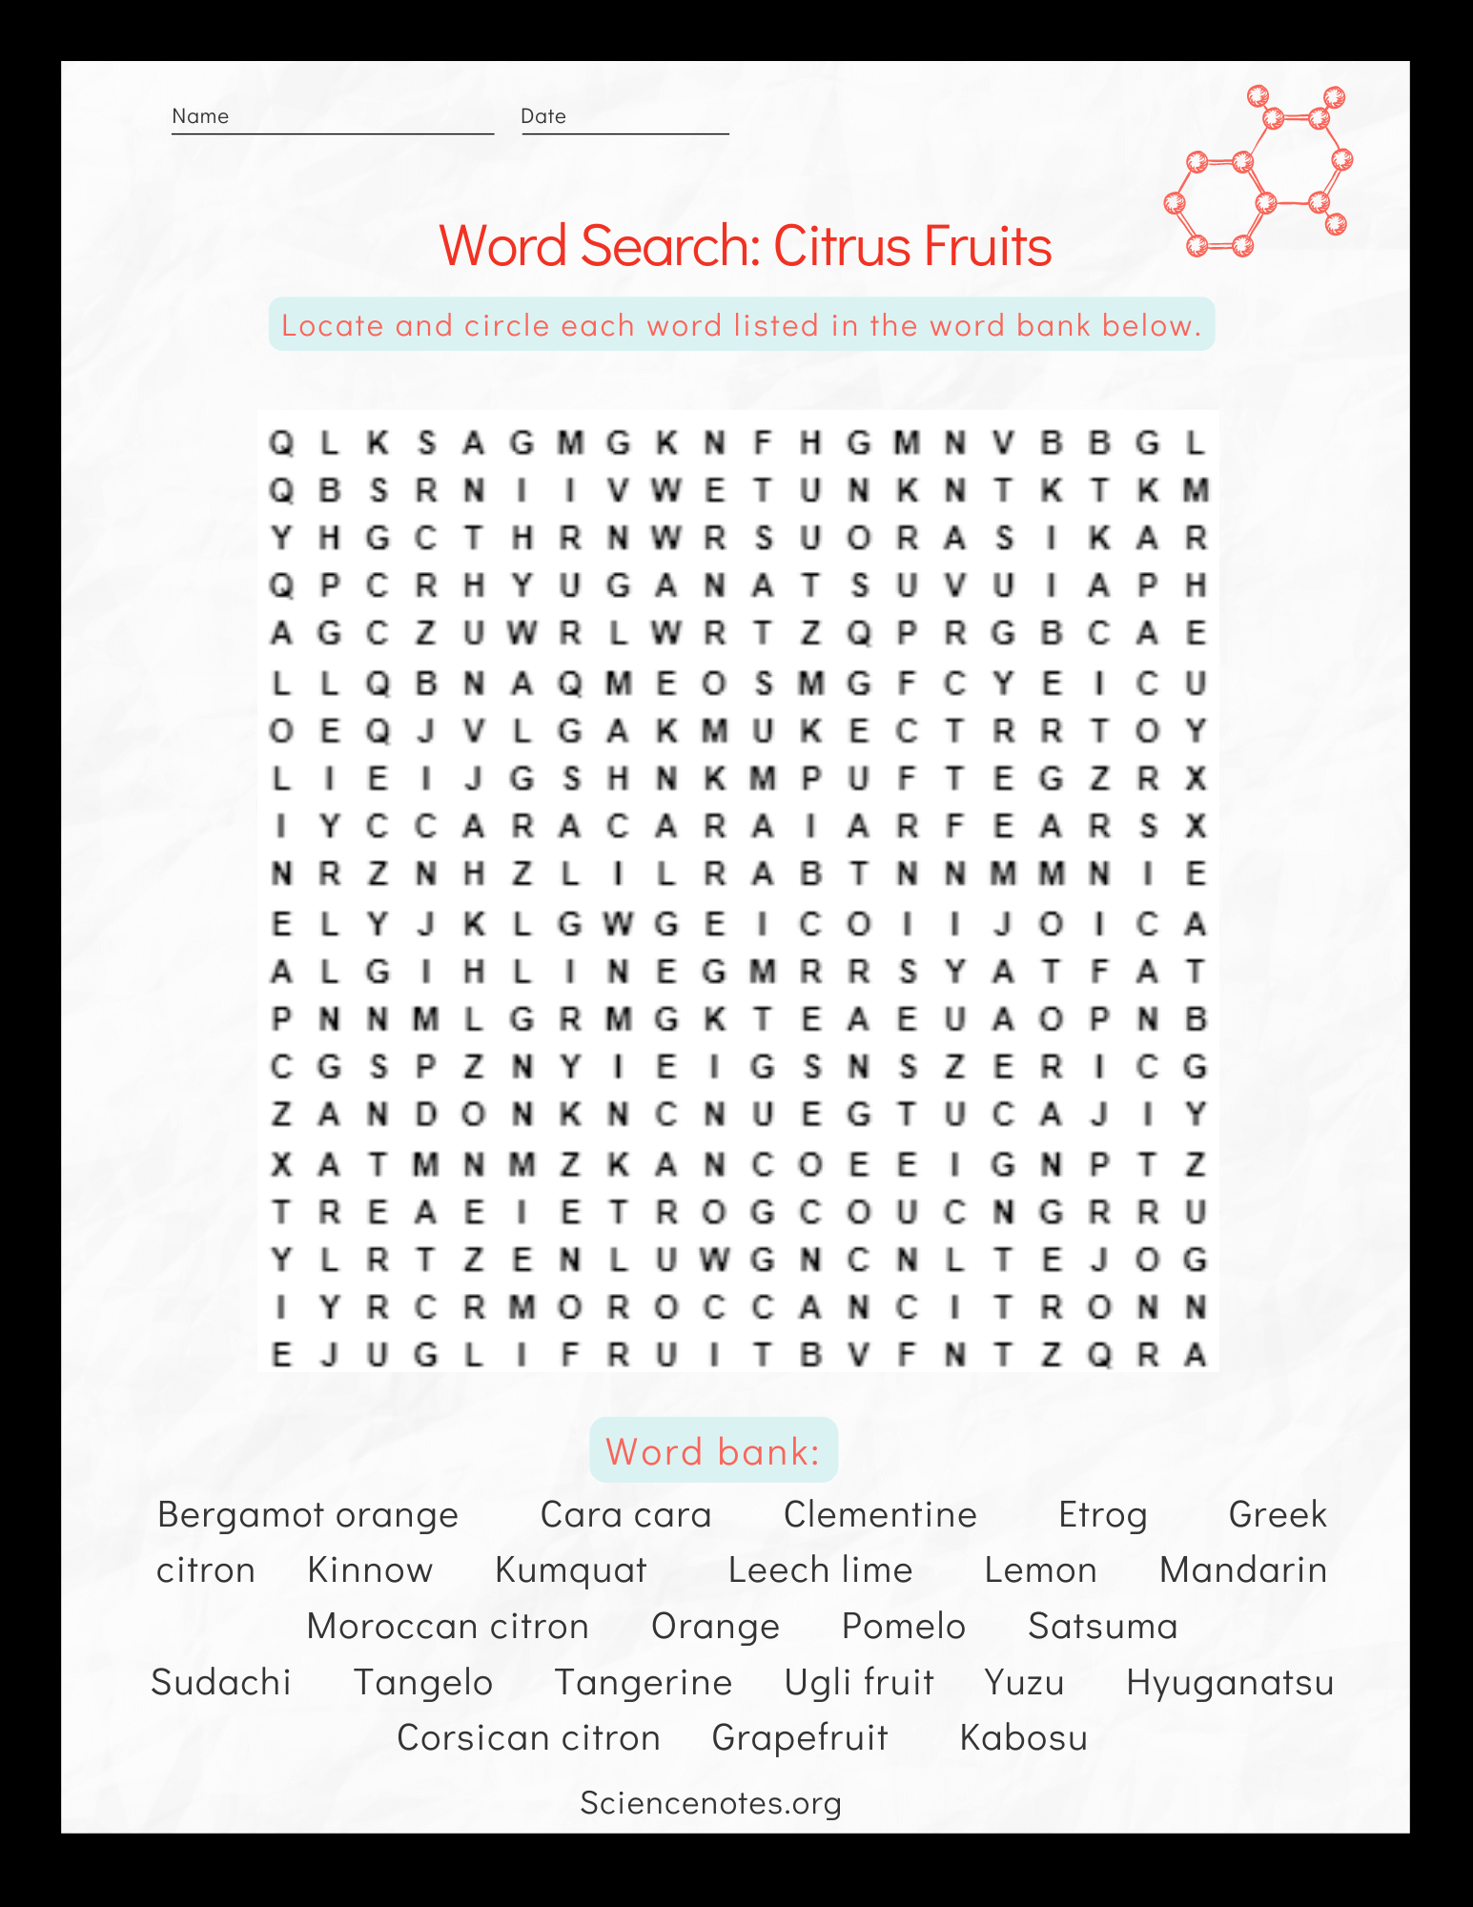

January 2025 TOPIC: Common Health Scams
Article courtesy of FTC Consumer Advice Part 1 of 4-part series

Five Ways To Avoid Health Scams
Companies might try to take advantage of your hope by making guarantees or promises that aren’t true about health products or services. Before you buy a health product or service:  - Do some research. See what other people are saying. Search for the name of the treatment or product online, plus the words “review,” “complaint,” or “scam.” | 
- Ask your doctor first. You might ask about the effectiveness of the treatment, its ingredients, if it’s safe to take (including with your other medications), and how much to take.

- Know that unproven products and treatments are risky. They can have bad interactions with other treatments. It’s also risky to stop or delay taking proven medical treatments, or to delay making other important changes to help your condition — like changes to your diet or lifestyle.

- Know that “natural” doesn’t mean safe or effective. In fact, “natural” can mean harmful and ineffective. And some “natural” products might interfere with proven treatments recommended by your doctor.

- Know that no government agency approves ads before they go public. Federal law says sellers that market cures must have scientific evidence to back up their claims, but dishonest companies might not. Ads must be truthful — not misleading.
Source: https://consumer.ftc.gov/articles/common-health-scams

January 2025 TOPIC: Common Health Scams
Article courtesy of FTC Consumer Advice Part 1 of 4-part series

 | Did you know….  People spend billions of dollars a year on products and treatments to try to improve their health and fitness. But a lot of that money goes to companies that make false claims, cheating people out of their money, their time, and even their health. We will spend the next 3 months talking about health and nutrition scams. If you’re thinking about buying a health product or service, here are some things to know.
Learn To Spot Common Health Scams
Dishonest companies will say anything to get you to buy their product or service. Learning the lies they tell helps you to spot and avoid scams.

- Dishonest companies tell you one product cures lots of different diseases and health problems. It won’t.

- Dishonest companies use fake endorsements from patients or doctors claiming, “you’ll get miraculous results.” You won’t.

- Dishonest companies say you’ll “get results in 30 days or we’ll refund your money.” You won’t get either.

- Dishonest companies say their special product will cure your condition. It won’t.

- Dishonest companies say you have to “act now.” You don’t.

- Dishonest companies use phony, scientific-sounding terms or refer to prestigious prizes, like the Nobel prize. But don’t take their word for it. Your doctor or health provider is your best and most important source of information on whether a product is safe for you.

January 2025 Easy Marinade
Author: Aberdeen

Citrus Marinade
A delicious, quick and easy triple citrus marinade made from freshly squeezed oranges, lemons, and limes with countless uses. Great for flavoring any type of protein, from chicken to tofu!

Ingredients  1/2 cup orange juice  1/4 cup lemon juice  1/4 cup lime juice  1 tablespoon orange zest  1 tablespoon lemon zest  1 tablespoon lime zest  1/4 cup green onion, thinly sliced  1 tablespoon shallot, minced | 4 cloves garlic, minced  1/4 cup cilantro, roughly minced  2 tablespoons low-sodium soy sauce  1 teaspoon Dijon mustard  2 tablespoons extra virgin olive oil  1 1/2 teaspoons coarse salt  1/2 teaspoon ground black pepper | 
Instructions
- In a large mixing bowl, whisk together all ingredients. That's it!
- See recipe notes for uses and marinating times. If making before using, store in an airtight container in the fridge for 3 to 4 days.

Notes
Proteins with which we enjoyed this citrus marinade:
- Chicken breasts - Let marinate in a bowl or Ziploc bag for 30 minutes, up to 4 hours. Cook as desired until internal temperature reaches 165˚F.
- Pork chops - Let marinate in a bowl or Ziploc bag for 30 minutes, up to 4 hours. Cook as desired until internal temperature reaches 145˚F. Drizzle with any remaining sauce.
- Shrimp - Let marinate in a bowl or Ziploc bag for 30 minutes. Pan fry and drizzle with any remaining sauce.
- Extra firm tofu - Press a tofu block to rid it of most of its water. Let marinate in a bowl or Ziploc bag for 30 minutes, up to 4 hours. Pan fry and drizzle with any remaining sauce.
- Assorted veggies - Just toss in the marinade, cook as desired, and drizzle with any remaining sauce.


MENU
JANUARY
2025

SENIOR DINING
More than a meal!



Meal Site Location Information To reserve your meal, call 715-373-3396

Barnes Town Hall  3360 County Hwy. N  Barnes, WI 54873 | Meal Days: Thursdays  Reservation required? Yes  Call by 9:00 a.m. the day before. | Site Opens: 11:30 a.m.  Meal Served: 12:00 noon
Bell Town Hall  22620 Ash Street  Cornucopia, WI 54827 | Meal Days: Tuesdays  Reservation required? Yes  Call by Monday at 8:30 a.m. | Site Opens: 11:30 a.m.  Meal Served: 12:00 noon
Cable United Church of Christ  13445 County Hwy. M  Cable, WI 54821 | Meal Days: 1st & 3rd Mondays of the month  Reservation required? Yes  Call by Thursday at 12:00 noon | Site Opens: 12:00 noon  Meal Served: 12:30 p.m.
Iron River Community Center  8275 E. Mill Street  Iron River, WI 54847 | Meal Days: 2nd & 4th Thurs. of the month  Reservation required? Yes  Call by Monday at noon | Site Opens: 11:30 a.m.  Meal Served: 12:00 noon
First Lutheran Church  83105 Washington Avenue  Port Wing, WI 54865 | Meal Days: Wednesdays  Reservation required? Yes  Call by Tuesday at 8:30 a.m. | Site Opens: 11:30 a.m.  Meal Served: 12:00 noon
Time Out Restaurant  4 Bayfield Street  Washburn, WI 54891 | Meal Days: Wednesdays  Reservation required? No  *Please be respectful of the restaurant and do not arrive earlier than 1:00 p.m. | Seating Opens: 1:00 PM*  Meal Served: 1:30 – 2:00 p.m.  Site Closes: 3:00 p.m.
St. Louis School  713 Washington Avenue  Washburn, WI 54891 | Meal Days: Fridays  Reservation required? Yes  Call by 3:00 p.m. Wednesday | Site Opens: 11:30 a.m.  Meal Served: 12:00 noon

Be sure to include your name, phone number, meal site location and date you are making the reservation, and how many people you are making reservations for.

Suggested contribution amount is $3.00 - $5.00 per meal. All contributions are used to fund the program.

k:\aging and disabilities\elder nutrition program\menus\current\2024 congregate\01-2024 menu february.docx

