

NOTICE/AGENDA

ROADS AND RIGHT OF WAY COMMITTEE MEETING

August 5, 2025

6:30PM, Town Garage

**AGENDA**

1. **Roll call, establish quorum, and verification of public notice**
2. **Approve minutes of 6/3/2025 meeting**
3. **Public comment -- 10 minute time limit enforced**

**Old Business**

1. **Driveway policy**
2. **River Road bridge**
3. **Funding Lake Road and bridge**

**New Business**

1. **Shoulder mowing**
2. **Sand and salt inventory**
3. **Webster Road and other washouts**
4. **Determine September meeting date (9/2 or 9/9)**
5. **Adjourn**

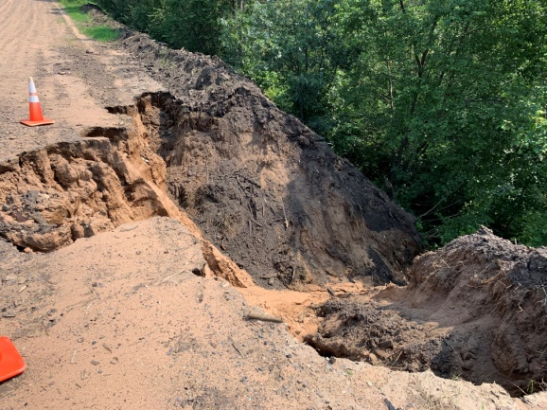 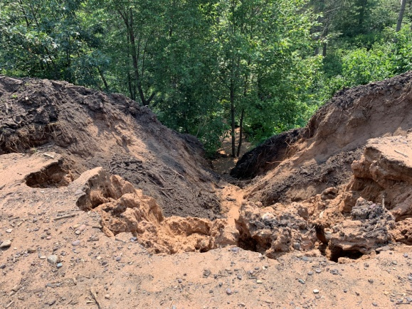

Submitted by Mark Holm

mhhusker@aol.com