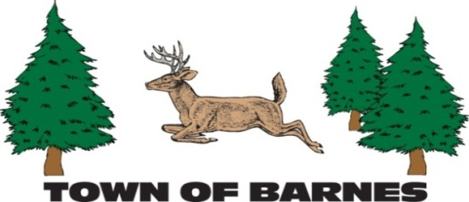

NOTICE/AGENDA

ROADS AND RIGHT OF WAY COMMITTEE MEETING

May 6, 2025

6:30PM, Town Garage

**AGENDA**

1. **Roll call, establish quorum, and verification of public notice**
2. **Approve minutes of 4/6/2025 meeting**
3. **Public comment -- 10 minute time limit enforced**

**Old Business**

1. **Meeting minutes posting**
2. **Road rating chart**
3. **Barnstormers MOU review**
4. **Ellison/Tomahawk intersect**

**New Business**

1. **River Road bridge**
2. **Review project log**
3. **Next meeting date (6/3)**
4. **Adjourn**

Submitted by Mark Holm

mhhusker@aol.com