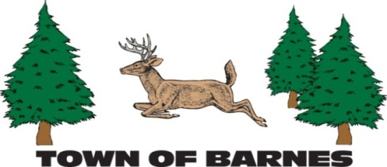

NOTICE/AGENDA

ROADS AND RIGHT OF WAY COMMITTEE MEETING

October 7, 2025

6:30PM, Town Garage

**AGENDA**

1. **Roll call, establish quorum, and verification of public notice**
2. **Approve minutes of 9/9/2025 meeting**
3. **Public comment -- 10 minute time limit enforced**

**Old Business**

1. **Lake Road structures and channel**
2. **Mowing and brushing review**
3. **Outlet Bay road**
4. **South Shore road**

**New Business**

1. **Review snow removal plans**
2. **Flow chart of structure maintenance**
3. **Determine November meeting date (11/4 or 11/11)**
4. **Adjourn**

Submitted by Mark Holm

mhhusker@aol.com