

MINUTES OF THE TOWN OF BARNES ROADS AND RIGHT OF WAY COMMITTEE

August 5, 2025

Members present were Doug Westerberg, Jeff Jordheim, Mark Holm, Chris Lane, Jack Gribble

Meeting called to order at 6:28 pm, quorum established by roll call

Motion to approve minutes of 6/3/2025 (Gribble/Lane) passed, no changes. No public comment.

**Lake Road bridge**

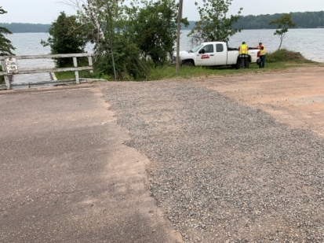A critical opening of approx 12 inches in the surface of Lake Road bridge was identified by the Highway Department foreman on August 4. A slide presentation was shown to the committee to illustrate extent of damage. Opening was repaired by town roads crew August 5 so that the road could be kept open to through traffic. During repair process, further inspection of the bridge revealed multiple structural faults that have accrued over time. Motion by Gribble, second by Lane:

*The committee recommends to the town board that this bridge be replaced at earliest possible time but no later than twelve months.*

Motion passed unanimously.

Special board meeting has been scheduled to address the problem.

**Old Business**

**Driveway policy**

This item was entered into the agenda specifically to discuss whether township can do work on a private drive. Research reveals there is no statutory authority that allows a town or county to contract to perform road work on private roads or driveways. In Heimerl, et.al. v. Ozaukee County, et.al., 256 Wis.151, 40 N.W.2nd 564, (1949) the Wis Supreme Court held that a statute authorizing such work was invalid.

**River Road bridge**

Divergence of public opinion on whether or not to replace River Road bridge was highlighted by a letter forwarded to the committee from a property owner. The bridge continues to be an ongoing concern to township and committee.

**New Business**

**Shoulder mowing and brushing**

Lengthy discussion regarding standards and practices for mowing and brushing township roads. Shoulder maintenance carries with it a subtle importance that extends to fire numbers, intersection visibility, and snow removal. Roads crew assigned to the work place high expectations on results -- but available personnel, equipment, and time create limits to what can be achieved over a summer season.

**Sand, salt, and gravel inventory**

Post rain evaluation indicates reduced inventory. Pricing increase subject to inflation. Winter sand and salt management strategy has already begun.

**Webster road washout**

Fourteen loads of fill were required to repair the washout.

**Adjourn**

Motion to adjourn (Lane/Westerberg) passed unanimously. Meeting adjourned 8:10pm.

Respectfully submitted, Mark Holm, recorder

**Next meeting Tuesday, September 9, 2025, 6:30pm at township garage**