

MINUTES OF THE TOWN OF BARNES ROADS AND RIGHT OF WAY COMMITTEE

March 4, 2025

Members present were Jack Gribble, Jim Frint, Doug Westerberg, Chris Lane, Mark Holm, Jeff Jordheim

Also present: Diane Rupnow, Nancy Walsh, Linda Mackley, Paul Korbein, Krisanne Korbein

Meeting called to order at 6:31 pm, quorum established by roll call

Motion to approve minutes of 2/4/2025 passed (Holm/Lane), no changes

There was no public comment. Motion (Holm/Lane): move up *Hwy 27 channel* for discussion, as a convenience to property owners in attendance. Passed unanimously

**Highway 27 channel**

Paul Korbein presented visual displays to illustrate damage to navigable waterway linking Bony Lake to Middle Eau Claire Lake. Annual ice damage to shoreline reinforcements is narrowing the channel to the extent it may become impassable over time. Because there is no boat launch facility on Boney Lake, lakeshore residents on Boney need the channel to gain access to Middle boat launch.

Committee is in agreement that maintenance of the channel and shoreline is beneficial to the community -- but finds difficulty in identifying who should be responsible, as well as in devising a workable solution.

Further research is needed. Jeff will check with town council to see if township can provide support for initial survey work.

**Building committee**

Tom Renz will appoint personnel for this ad hoc committee.

**Roads rating system**

Discussion regarding which roads will be reviewed. Table to April meeting.

**Barnstormers**

Barnstormers Snowmobile Club has submitted a memorandum of understanding to the township “concerning the maintenance and safety of snowmobile trails within the town road right-of-way.” Primarily the Barrnstormers seek to have more snow left by roads crew for trail grooming along certain identified roads.

Committee unequivocally supports Barnstormers and other area snowmobilers -- and wishes to help maintain the many benefits these groups bring to local merchants and businesses. Barnes Highway Department will take these concerns under advisement while concurrently endeavoring to continue to provide safe and passable roadways in winter.

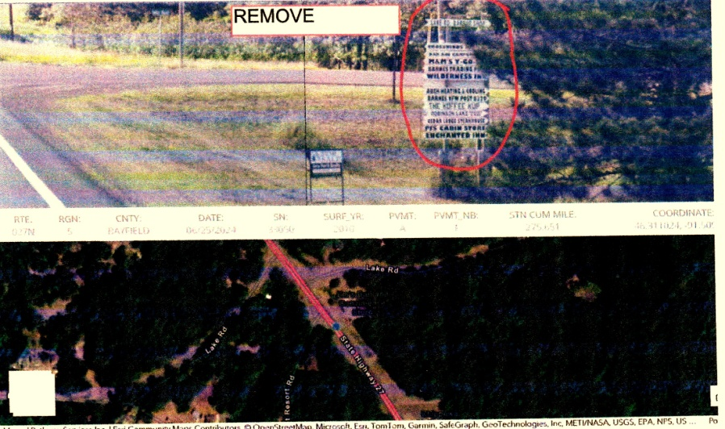**New truck**

No new information at this time.

**Highway 27 road signs**

Matthew A. Reddy, PE, Traffic/Signing/Pavement Engineer for Wisconsin Department of Transportatio has communicated to Jeff advising that WisDOT will be replacing all signs throughout the state along STH 27. His review indicates that various white arrow board type signs in the 27 right-of-way are not permittable and must be removed. Committee discussed cost and financing of these signs. No current action to be taken.

**Adjourn**

Motion to adjourn (Lane/Friint) passed unanimously. Meeting adjourned 7:49pm.

Respectfully submitted, Mark Holm, recorder

**Next meeting Tuesday, April 8, 2025, 6:30pm, at township garage**