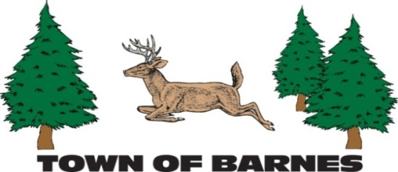

NOTICE/AGENDA

PARKS AND RECREATION

COMMITTEE MEETING

Thursday, July 10, 2025

9:30 am at the Barnes Town Office & via Zoom Video Conferencing

Zoom Link: <https://us06web.zoom.us/j/81765484128>

Meeting ID: 817 6548 4128

**AGENDA**

1. Call Meeting to order, Roll call and verification of public notice.
2. Welcome to Dave Scully (if in attendance)
3. Approve the Agenda
4. Approve the minutes of previous meetings
5. Snowshoe trail construction complete. Signage sub committee
6. Snowshoe grant (Bayfield County Health and Wellness grant) – report submitted - Volunteer hours?
7. TLP garage (update from Dave) Delivery on Friday and Tuesday
8. Pickleball court surface repair (Kay)
9. Playground equipment (Terry, Barb, Kay)
10. Budget update
11. Old business
12. New business
13. Next Meeting Date – July 10th, 2025 (Blair will be present!)
14. Adjourn

Year 1 – Blair Gagne (second 3-year term), New member (to be determined)

Year 2 – Barb King, (1st term), Kay Erdahl (3rd 3-year term), Terry Kolberg (3rd 3-year term)

Year 3 – Mark Sutton (1st term), Dawn Piburn (1st term)

Current officers – Chairperson – Blair Gagne, Vice Chairperson – Mark Sutton Secretary – Terry Kohlberg

Budget funds as of 8-31-2024 (Parks and Rec). P&R Sinking fund - $7,080.41, TLP Sinking fund - $11,660.93,

TLP Donations - $895.00, Park Outlay - $30,000.00 (garage – will rollover into 2025 if not completed)

Submitted by Blair Gagne (Parks and Recreation committee chairperson)

218-393-0557 blairjgagne@gmail.com