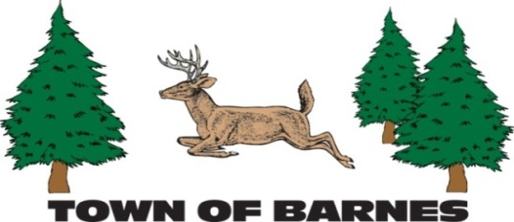

NOTICE/AGENDA

PARKS AND RECREATION

COMMITTEE MEETING

Thursday, April 10, 2025

9:30 am at the Barnes Town Office & via Zoom Video Conferencing

Meeting link: <https://us06web.zoom.us/j/89845510321>

Meeting ID: 898 4551 0321

**AGENDA**

1. Call Meeting to order, Roll call and verification of public notice
2. Approve the Agenda
3. Approve the minutes of previous meetings
4. Snowshoe trail construction (3rd Loop)
5. Snowshoe grant (Bayfield County Health and Wellness grant)
6. TLP garage timeline (need for volunteers)
7. Memorial garden
8. Playground equipment (Terry, Barb, Kay)
9. Skating rink/warming house winter use
10. TLP beach maintenance/raft
11. Old business Replacement for Marc Lybeck on committee and vice chair position
12. New business
13. Next Meeting Date – May 8th, 2024
14. Adjourn

Year 1 – Blair Gagne (second 3 year term), New member (to be determined)

Year 2 – Barb King, (1st term), Kay Erdahl (3rd 3 year term), Terry Kolberg (3rd 3 year term)

Year 3 – Mark Sutton (1st term), Dawn Piburn (1st term)

Current officers – Chairperson – Blair Gagne, Vice Chairperson - ???, Secretary – Terry Kohlberg

Budget funds as of 8-31-2024 (Parks and Rec). P&R Sinking fund - $7,080.41, TLP Sinking fund - $11,660.93,

TLP Donations - $895.00, Park Outlay - $30,000.00 (garage – will rollover into 2025 if not completed)

Submitted by Blair Gagne (Parks and Recreation committee chairperson)

218-393-0557 [parkrec@townofbarneswi.gov](mailto:parkrec@townofbarneswi.gov)