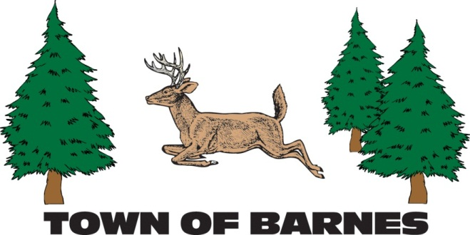

ANNUAL TOWN MEETING

Tuesday, April 15, 2025

6:00 pm at Barnes Town Hall

Join via Zoom: https://us06web.zoom.us/j/86793033791

Meeting ID: 867 9303 3791

**AGENDA**

1. **STATE OF THE TOWN REPORTS**

* **Spring Election Results(Swear-ins)**
* **Annual Report from the Chair**
* **Garage Presentation**
* **Annual Highway Department Report**
* **Annual Transfer Site Report**
* **Annual Ambulance and Fire Departments Report**

**2) Any other issues authorized by Wi. Statute 60.10**

Submitted by: Kari Hufnagle, Town of Barnes Clerk-Treasurer

715-795-2782 or Email: clerk@townofbarneswi.gov