Senior Dining Menu – Greater Bayfield County November 2024

Meal Reservation Line – (715) 373-3396

MONDAY | TUESDAY | WEDNESDAY | THURSDAY | FRIDAY
 |  |  |  | 1
 |  |  |  | NO MEAL
4 | 5 | 6 | 7 | 8
Roast Chicken Breast  Mashed Potatoes  Chicken Gravy  Green Beans  Pineapple Chunks  Whole Wheat Bread | Brown Sugar  Glazed Ham  Peas and Carrots  Baked Beans  Fresh Fruit  Whole Wheat Bread | Spaghetti & Meatballs  Side Salad  Sliced Cucumbers  Diced Peaches  Ranch | Salisbury Steak  Mashed Potatoes  Brown Gravy  Pickled Beets  Peach Cobbler | NO MEAL
11 | 12 | 13 | 14 | 15
Veteran’s Day  OFFICES CLOSED  No Meals | Lasagna  Mixed Vegetables  Canned Peaches | Meatloaf  Mashed Potatoes  Brown Gravy  Steamed Broccoli  Fresh Fruit  Whole Wheat Bread | Roast Pork Loin  Baked Potato  Brown Gravy  Baked Beans  Fresh Fruit  Dinner Roll  Sour Cream | NO MEAL
18 | 19 | 20 | 21 | 22
Beef Shepard's Pie  California Vegetable Blend  Fresh Fruit  Whole Wheat Dinner Roll | Swedish Meatballs  Mashed Potatoes  Brussels Sprouts  Honeydew  Whole Wheat Dinner Roll | Chicken Broccoli Alfredo  Italian Vegetables  Fresh Fruit | Roast Turkey  with Gravy  Roast Butternut Squash  Cranberry Sauce  Apple Crisp  Whole Wheat Dinner Roll | NO MEAL
25 | 26 | 27 | 28 | 29
Rotisserie Seasoned Chicken  Steamed Carrots  Baked Beans  Chicken Gravy  Fresh Fruit  Whole Wheat Dinner Roll | Broccoli Cheese Soup  Egg Salad  White Slider Bun  Lettuce Leaf  Sliced Tomatoes  Dill Pickle Slices  Mustard  Fresh Fruit | Sweet and Sour Pork  Brown Rice  Oriental Vegetable Blend  Pineapple Tidbits | Thanksgiving Day  OFFICES CLOSED  No Meals | Thanksgiving Holiday  OFFICES CLOSED  No Meals
NOTE: Menus are subject to change without notice.

SQUASH SCRAMBLE
Unscramble the squash types below to reveal the phrase.

Acorn Squash | Butternut Squash | Hubbard Squash | Sugar Pumpkin
Banana Squash | Carnival Squash | Kabocha Squash | Sweet Dumpling Squash
Buttercup Squash | Delicata Squash | Spaghetti Squash | Turban Squash

UBETPRTUC |  |  |  |  |  |  |  |  |  |  | RUBANT
 |  |  | 19 |  | 12 | 9 |  |  |  |  |  |  |  | 17 |  |  | 6
GAUSR |  |  |  |  |  |  |  |  |  |  | THISPAGET
 |  |  | 16 | 3 |  |  |  |  |  |  |  | 1 |  |  |  |  | 14
RABHUDB |  |  |  |  |  |  |  |  |  |  | ANABAN
 |  | 22 |  |  |  | 15 |  |  |  |  |  | 13
LATECAID |  |  |  |  |  |  |  |  |  |  | BRETUTUTN
 | 23 | 2 |  |  |  |  | 21 |  |  |  |  |  |  |  | 7 | 24
BAHOCAK |  |  |  |  |  |  |  |  |  |  | NARCO
 |  | 18 |  | 8 |  |  |  |  |  |  |  |  |  | 5
NACRILAV
 |  |  |  |  | 20

WESTE PLUMGIND
 | 4 |  |  | 10 |  |  |  |  | 11
Phrase:
1 | 2 | 3 | 4 | 5 | 6 |  | 7 | 8 |  | 9 | 10 | 11 | 12 | 11 | 13 | 14 | 15
16 | 17 | 18 | 19 | 20 | 21 | 22 | 23 | 24

November 2024 BRAIN HEALTH
Article and Information from National Institute of Health and Why You Should Care?
Quora: Author James Miguel (11-03-2023)

Did you know…. November is also Brain Health & Alzheimer’s Awareness Month?

The average adult human brain weighs three pounds and has a texture like firm jelly.
Every time your heart beats, your arteries carry 20 – 25 percent of your blood to the brain.
Every time you recall a memory or have a new thought, you create a connection in the brain.
It takes only 2% dehydration to affect your attention, memory and other cognitive skills.

Brain health is crucial because it encompasses the functionality and well-being of one of our most vital organs—the brain. It is the epicenter of our nervous system, a complex command center orchestrating everything from our motor skills to our emotional responses. When our brain is functioning optimally, we can think clearly, learn new information, and regulate our emotions. Conversely, when brain health deteriorates, it can significantly affect memory, cognition, and quality of life. Factors such as mental health, physical fitness, sleep quality, and nutrition all contribute to brain health. Diseases like Alzheimer’s and dementia are associated with cognitive decline, underscoring the importance of maintaining brain health to prevent such diseases. Furthermore, the brain's plasticity means that it has the remarkable ability to change throughout life, adapting to new information or recovering from injuries, which can be supported by healthy lifestyle choices.

To maintain and improve brain health, one can engage in various activities and lifestyle practices. Regular physical exercise is one of the most beneficial, with research indicating that it can improve cognitive function and may reduce the risk of cognitive decline with age. Mental stimulation through learning new skills, reading, or playing musical instruments can also foster new neural connections. Additionally, social interaction is known to ward off brain health issues, potentially reducing risks of depression and cognitive impairment. A balanced diet rich in omega-3 fatty acids, antioxidants, and vitamins, particularly those found in fruits, vegetables, and fish, is also linked to better brain health.

Furthermore, adequate sleep and stress management are essential for brain health. Sleep is crucial for memory consolidation and clearing brain toxins that accumulate throughout the day. Managing stress through mindfulness, meditation, or therapy can mitigate the adverse effects of stress hormones on the brain. Avoiding harmful substances, such as excessive alcohol and drugs, is also vital for maintaining brain structure and function. In essence, a holistic approach encompassing physical health, mental engagement, social interaction, and proper nutrition is key to sustaining a healthy brain. By investing in our brain health, we are setting the stage for a better quality of life now and as we age.

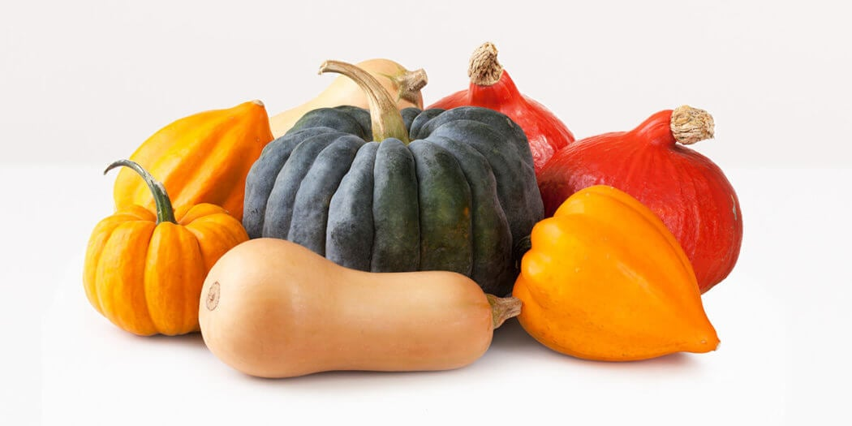 | 12 Common Types of Winter Squash
Acorn Squash | Butternut Squash | Hubbard Squash | Sugar Pumpkin
Banana Squash | Carnival Squash | Kabocha Squash | Sweet Dumpling Squash
Buttercup Squash | Delicata Squash | Spaghetti Squash | Turban Squash

How do I buy winter squash?
Always choose a firm squash with no blemishes, bruises or soft spots. The skin should be dull, not glossy. The stem should be intact, and the squash should feel heavy for its size.

How do I prepare winter squash?
To prepare winter squash, remove the skin with a knife or vegetable peeler, cut it in half, and remove the seeds and fibers. Roasting is one of the most common cooking methods for winter squash. You can also put winter squash in a slow cooker and roast squash seeds the same way you make roasted pumpkin seeds.

How do I store winter squash?
One of the great advantages of winter squash is its long shelf life—assuming you store it properly. Store whole winter squash in a cool, dry and well-ventilated space that’s between 45 and 50 degrees. Once cut, cover winter squash tightly with plastic wrap and keep it in the fridge for up to 5 days. Baked or steamed squash can be frozen to use later in soups, as well as casseroles, breads, muffins and pies.

Is squash healthy?
Yes! Winter squash is packed with complex carbohydrates; dietary fiber; manganese; folate; vitamins A, B6 and C; and loads of antioxidants. It’s also a great low-calorie option if you’re on a diet.

What is the difference between winter squash and summer squash?
Winter squash is commonly available from late summer through the mid-winter months. Aside from this seasonality, winter squash differs from summer squash in that it’s generally sweeter, denser and firmer. Winter squash also has a harder outer skin.

Across | BRAIN HEALTH CROSSWORD PUZZLE
2. Lifelong _______ can increase brain health. |  |  |  |  |  |  |  |  |  | 1
4. Things that are good for your  _______ are also good for your brain. |  |  |  |  | 2 |  | 3
5. _______ your weight, blood pressure, cholesterol, and blood
sugar can improve brain health. |  |  | 4
7. _______ your intake of protective foods.
8. _______ exercise is essential for maintaining good blood flow to the |  |  |  |  |  | 5
brain. |  |  |  | 6
9. Physical exercise does not have to be _______ to be effective |  |  |  |  |  |  | 7
12. Most ______-skinned fruits and vegetables have the highest levels of
naturally occurring antioxidants. | 8
Down
1. Cold water ______ contain beneficial omega-3 fatty acids.
3. Foods that are high in _______ are considered protective foods. |  |  |  |  |  |  | 9 |  | 10 |  |  |  |  |  | 11
6. Some _____ are a good source of Vitamin E, which is an antioxidant.
10. _______ your intake of foods that are high in fat and cholesterol. |  |  |  |  |  |  |  |  | 12
11. _______ interaction helps to maintain brain vitality.
Word Bank
Antioxidants Controlling Fish Dark Heart Increase
Learning Nuts Physical Reduce Social Strenuous

FoodHero.org |  |  | Roasted Honey Mustard Brussels Sprouts
Prep time: 10 minutes Cook time: 10 minutes Makes: 2 cups
Ingredients: | 2 cups halved Brussel sprouts  1 Tablespoon honey or brown sugar  ½ teaspoon onion powder |  |  | 2 teaspoons margarine or butter, melted  1 teaspoon mustard
Instructions: | 1.) Preheat oven to 450°F.  2.) Mix margarine (or butter), honey, mustard, and onion powder in a large bowl. Set aside.  3.) Spread sprouts on baking pan and roast for 10-15 minutes, or until tender.  4.) Add roasted sprouts to the mustard mixture and stir until evenly coated.
Notes: | Serve warm. Refrigerate leftovers within 2 hours.
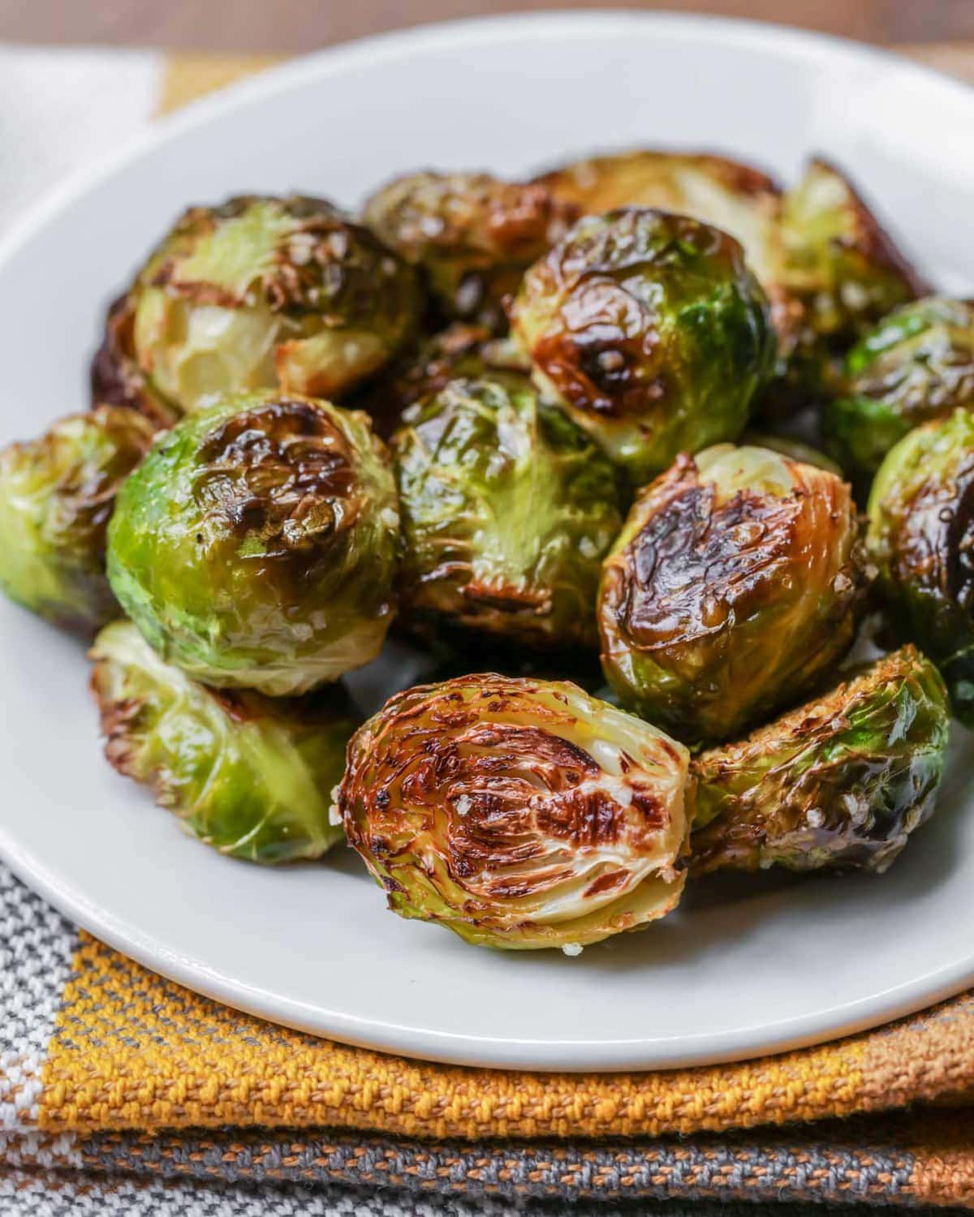 |  | Bon Appetite! |  |  | 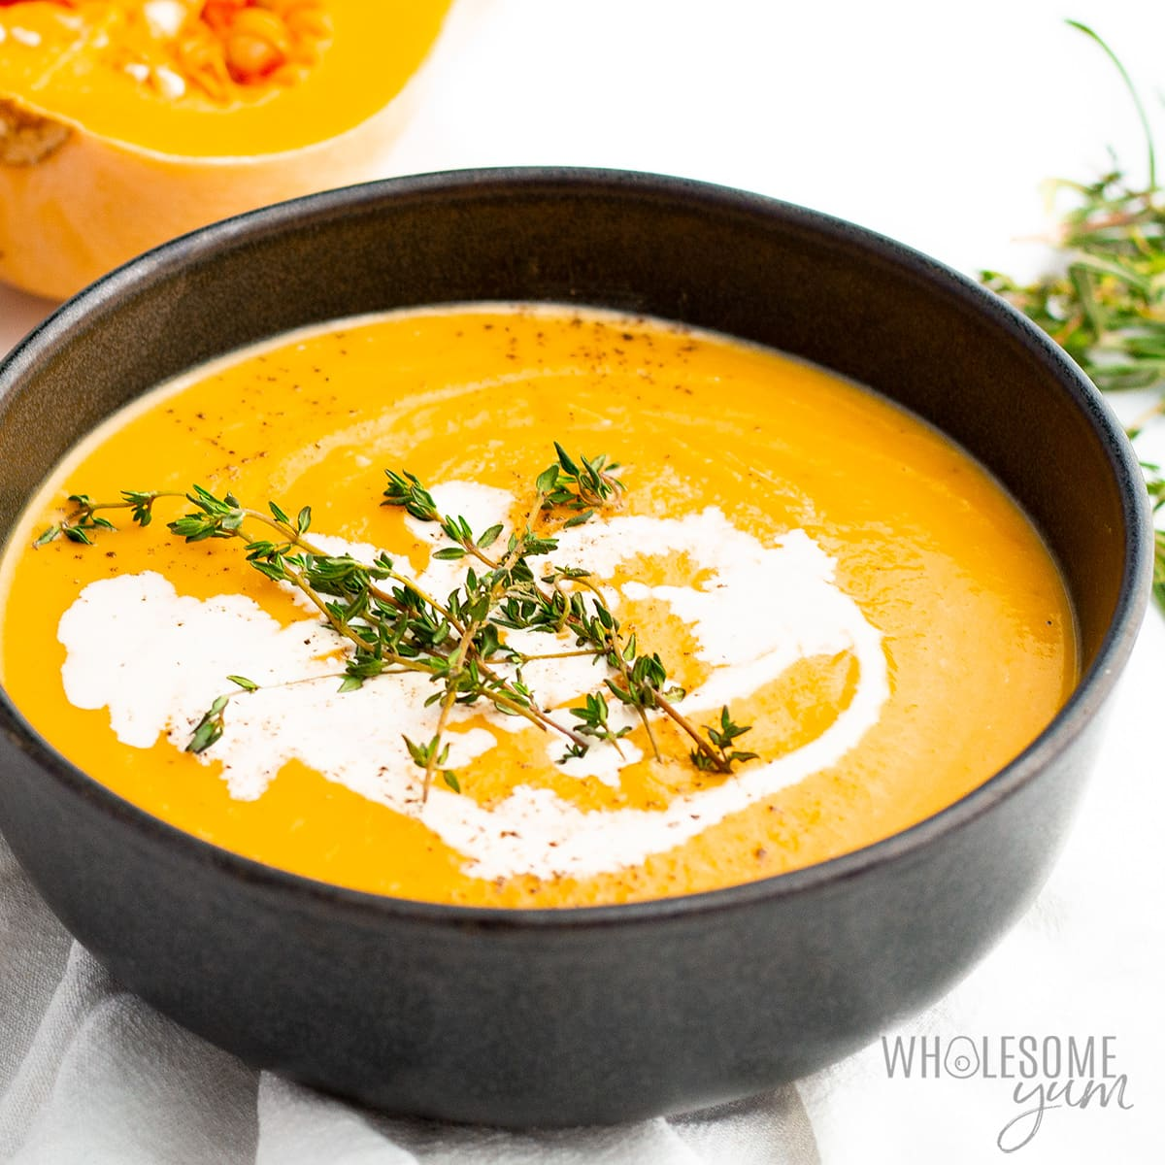
Taste of Home.com |  |  | Butternut Squash Soup
Prep time: 15 minutes Cook time: 15 minutes Makes: 9 servings (2 ¼ quarts)
Ingredients: | 1 tablespoon olive oil  3 garlic cloves, minced  4 cups vegetable broth  ¼ teaspoon pepper |  |  | 2 teaspoons margarine or butter, melted  1 teaspoon mustard  Optional: Additional heavy whipping cream and crispy sage leaves.
Instructions: | 1.) In a large saucepan, heat oil over medium heat. Add onion; cook and stir until tender.  Add garlic; cook 1 minute longer.  2.) Stir in squash, broth, salt and pepper; bring to a boil. Reduce heat; simmer, covered for  10-15 minutes or until squash is tender.  3.) Puree soup using an immersion blender, or cool slightly and puree soup in batches in a  Blender; then return to the pan.  4.) Add cream; cook and stir until heated through.
Notes: | If desired, garnish with additional heavy whipping cream and crispy sage.

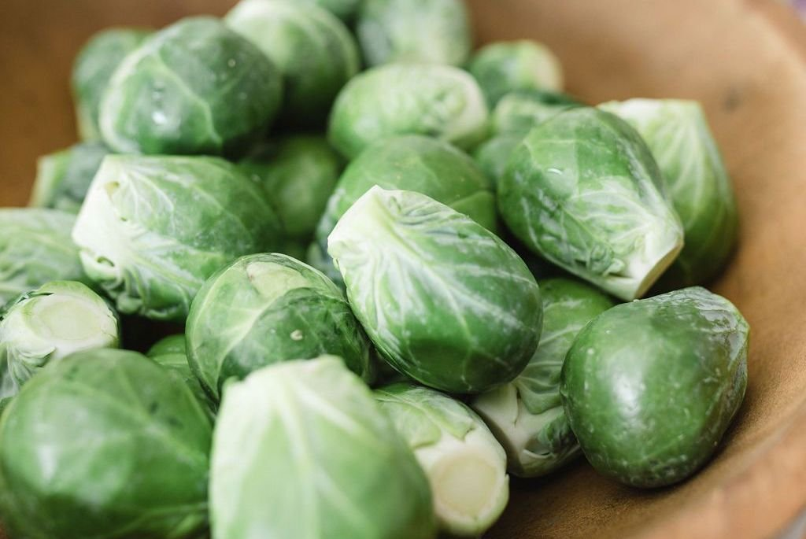 |  | Good ‘ole sprouts. Did you know that Brussels sprouts….  Really are named after Brussels, the capital of Belgium, where they were a popular 16th century crop. The brussels sprout was introduced to North America by 18th century French settlers in Louisiana.
Fun Facts: | - The U.S. produces 70 million pounds of sprouts each year.  - The sulforaphane that gives Brussels sprouts their unique flavor also helps lover cancer risks.  - Brussels sprouts contain zeaxanthin, an antioxidant that is considered important to eye health.  - A little under one ounce of these vegetables provides 6 grams of fiber and 5 grams of protein.  - One 80-gram serving of these delivers four times more vitamin C than an orange.
Brussels Sprout Word Search
Word List:  BITTER  BRUSSELS SPROUT  BUNCHES  CABBAGE  CHIPS  GREEN  LEAVES  ROAST  ROUND  STEM |  | 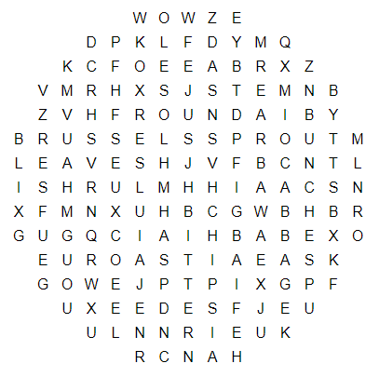

November 2024 EAT WELL, AGE WELL
Article courtesy of GWAAR Nutrition Team (11/23) Winter Squash & Brussels Sprouts
Compliments of Great Lakes Intertribal Council

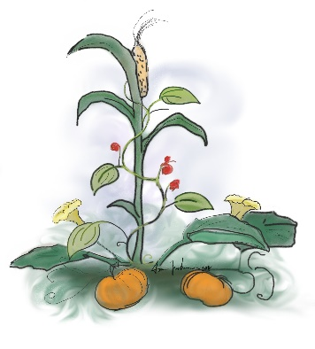 | Did you know….  Native American Heritage Month is recognized in November, and first evolved from "American Indian Week,” which President Reagan proclaimed on the week of November 23-30, 1986. In 1990, President George H. W. Bush approved a joint resolution designating November 1990 as National American Indian Heritage Month. It was later changed to Native American Heritage month under President Barack Obama.
According to the 2020 U.S. Census 2.5% of Wisconsin residents identified as being American Indian and Alaska Native alone or in combination. The counties with the highest populations include Menominee, Sawyer, Forest, Ashland, Bayfield, Vilas, Shawano and Jackson. Which makes since because there are tribal communities or reservations located within those counties.

Three Sisters Planting: A Native American Tradition
The intercropping method of planting corn, beans and squash together, commonly called the Three Sisters has been studied and described by scholars in anthropology, history, agriculture, and food studies for many years. While this practice is often cited in current sources as a way to improve small gardens for individual use, its historical value lay in larger-scale implementations designed to nurture and sustain entire communities.

This ancient style of companion planting has played a key role in the survival of all people in North America. Grown together, these plants are able to thrive and provide high-yield, high-quality crops with a minimal environmental impact. Corn beans, and squash have a unique symbiotic relationship in a Native American garden. Corn offers a structure for the beans to climb. The beans, in turn, help to replenish the soil with nutrients. And the large leaves of squash and pumpkin vines provide shade to trap moisture in the soil conserving water and providing weed control.

Coloring Page



MENU
NOVEMBER
2024

SENIOR DINING
More than a meal!



Meal Site Location Information To reserve your meal, call 715-373-3396

Barnes Town Hall  3360 County Hwy. N  Barnes, WI 54873 | Meal Days: Thursdays  Reservation required? Yes  Call by 9:00 a.m. the day before. | Site Opens: 11:30 a.m.  Meal Served: 12:00 noon
Bell Town Hall  22620 Ash Street  Cornucopia, WI 54827 | Meal Days: Tuesdays  Reservation required? Yes  Call by Monday at 8:30 a.m. | Site Opens: 11:30 a.m.  Meal Served: 12:00 noon
Cable United Church of Christ  13445 County Hwy. M  Cable, WI 54821 | Meal Days: 1st & 3rd Mondays of the month  Reservation required? Yes  Call by Thursday at 12:00 noon | Site Opens: 11:30 a.m.  Meal Served: 12:00 noon
Iron River Community Center  8275 E. Mill Street  Iron River, WI 54847 | Meal Days: 2nd & 4th Thurs. of the month  Reservation required? Yes  Call by Monday at noon | Site Opens: 11:30 a.m.  Meal Served: 12:00 noon
First Lutheran Church  83105 Washington Avenue  Port Wing, WI 54865 | Meal Days: Wednesdays  Reservation required? Yes  Call by Tuesday at 8:30 a.m. | Site Opens: 11:30 a.m.  Meal Served: 12:00 noon
Time Out Restaurant  4 Bayfield Street  Washburn, WI 54891 | Meal Days: Wednesdays  Reservation required? No  *Please be respectful of the restaurant and do not arrive earlier than 1:00 p.m. | Seating Opens: 1:00 PM*  Meal Served: 1:30 – 2:00 p.m.  Site Closes: 3:00 p.m.
St. Louis School  713 Washington Avenue  Washburn, WI 54891 | Meal Days: Fridays  Reservation required? Yes  Call by 3:00 p.m. Wednesday | Site Opens: 11:30 a.m.  Meal Served: 12:00 noon

Be sure to include your name, phone number, meal site location and date you are making the reservation, and how many people you are making reservations for.

Suggested contribution amount is $3.00 - $5.00 per meal. All contributions are used to fund the program.

