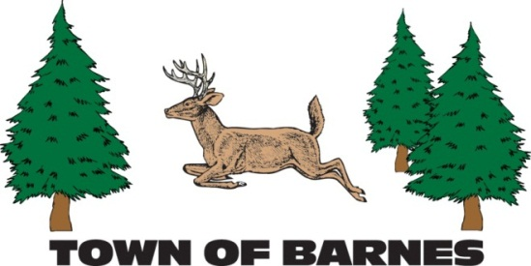

M E E T I N G N O T I C E

SPECIAL TOWN MEETINGS

|  |
| --- |
| Tuesday, November 19, 2024  6:00 p.m. at the Barnes Town Hall  **ANNUAL PUBLIC BUDGET HEARING**  **followed by** |
| **SPECIAL TOWN ELECTORS MEETING**  **to vote on the 2024 total town tax levy to be collected in 2025** |

**REGULAR MONTHLY TOWN BOARD MEETING**

**will immediately follow the budget meeting**

**The Agenda will be posted and also available on the Town Web Site: www.townofbarneswi.gov**

**Submitted by: Lisa Meyer, .Clerk-Treasurer**

**715-795-2782 clerk@townofbarneswi.gov**