Senior Dining Menu – Greater Bayfield County February 2025

Meal Reservation Line – (715) 373-3396

MONDAY | TUESDAY | WEDNESDAY | THURSDAY | FRIDAY

3 | 4 | 5 | 6 | 7
Chicken Chop Suey  Asian Blend  Vegetables  Pineapple Tidbits  Brown Rice | Beef Macaroni  Tomato Casserole  Chopped Romaine  Sliced Cucumber  Tomato Wedges  Ranch Dressing  Fruit Cocktail | Baked Chicken  With Thyme & Gravy  Mashed Potatoes  Steamed Broccoli  Canned Peaches  Wheat Dinner Roll | Sloppy Joe  Herb Roasted Potatoes  Baked Beans  Fresh Fruit  Bun | NO MEAL
10 | 11 | 12 | 13 | 14
Chicken ala King  Steamed Brown Rice  Steamed Beets  Fruit Cocktail | Chef Salad  Romaine Lettuce  Tomato Wedges  Sliced Cucumbers  Diced Ham  Shredded Cheese  Canned Peaches  Ranch Dressing  Whole Wheat  Dinner Roll | Maple Glazed Pork  Tomato Onion Salad  Baked Beans  Applesauce  Whole Wheat Bread | Lemon Baked Chicken  Brussels Sprouts  Mashed Potatoes  Chicken Gravy  Canned Peaches  Red Velvet Cake | NO MEAL
17 | 18 | 19 | 20 | 21
Italian Meatballs  Penne Pasta  Marinara Sauce  Italian Vegetables  Fresh Fruit | Turkey & Cheese  Burrito  Refried Beans  Shredded Romaine  Diced Tomatoes  Canned Pears | BBQ Chicken  Green Beans  Potato Salad  Fresh Fruit  Whole Wheat  Dinner Roll | Garlic Herb Pork Loin  Peas & Carrots  Mashed Potatoes  Pork Gravy  Blueberry Buckle | NO MEAL
24 | 25 | 26 | 27 | 28
Pepperoni Pizza Bake  Italian Vegetables  Fresh Fruit | Baked Haddock  White Wine Sauce  Steamed Carrots  Canned Pears  Wheat Roll  Baked Potatoes  Sour Cream | Kielbasa Sausage  Baked Beans  Sauerkraut  Whit Hot Dog Bun  Fruit Cocktail | Chicken Alfredo  Steamed Broccoli  Three Bean Salad  Fresh Fruit | NO MEAL

NOTE: Menus are subject to change without notice.

February 2025 TOPIC: Common Health Scams
Article courtesy of FTC Consumer Advice Part 2 of 4-part series

Anti-Aging Products  Despite claims about pills and treatments leading to the fountain of youth, there’s nothing you can buy that has been proven to slow or reverse the aging process. And many companies selling these lotions, creams, and supplements don’t have sufficient scientific evidence to show they work.  One common anti-aging health scam involves human growth hormone (HGH), a substance released by the pituitary gland that causes children and adolescents to grow. But here’s what to know about HGH: The FDA says there’s no clear evidence to support anti-aging claims for over-the-counter pills and sprays that supposedly contain HGH. The agency has not approved any of these products for anti-aging effects. | 
Arthritis
Symptoms of arthritis can come and go, so it can be easy to think a “treatment” or supplement is the answer. But there’s no cure for arthritis. In fact, some products could be harmful. No arthritis remedies have adequate scientific evidence that they’ll relieve your symptoms — that includes mussel extract, desiccated liver pills, shark cartilage, CMO (cetylmyristoleate), honey and vinegar mixtures, and gimmicks like magnets and copper bracelets.

For the most up-to-date and reliable information on arthritis treatments and alternative therapies, go to the Arthritis Foundation website or call them at 1-800-283-7800. Or get more information from the Centers for Disease Control and Prevention.

Source: https://consumer.ftc.gov/articles/common-health-scams

Chocolate Word Search
http://homeschooling.about.com

Words:  Pod  Chocolatl  Cocoa  Cacao tree  Pulp  Cacao beans  Theobroma cacao  Midges  Christopher Columbus  Cocoa butter  Currency | 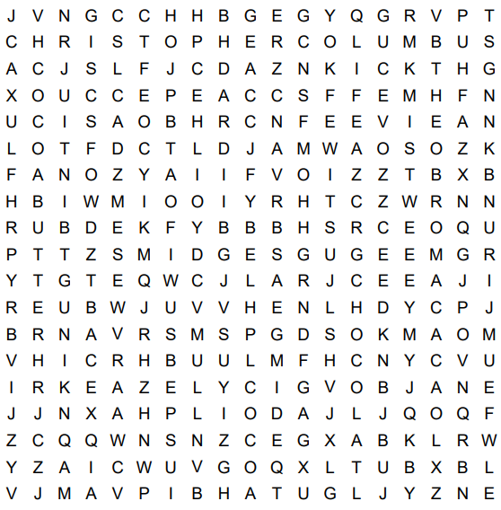

February 2025 TOPIC: Common Health Scams
Article courtesy of FTC Consumer Advice Part 2 of 4-part series

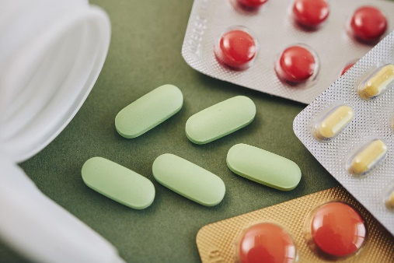 | Did you know….  Last month, we talked about the billions of dollars wasted on health and nutrition scams. The second article in this 4-part series will address some common health scams for certain common conditions. Here’s what to know about some common health scams.
Alzheimer’s Disease, Dementia, and Memory Loss

Alzheimer’s disease, dementia, and memory loss don’t have a scientific cure. The truth is…

- Just because a seller says their products are scientifically proven to work doesn’t mean they’re safe or effective. Many products that say they’ll help with memory loss or dementia are called “dietary supplements” or “natural remedies.” But the FDA doesn’t test these products to make sure they work or they’re safe. Some examples include ginkgo biloba, fish oil, grape seed extract, curcumin, Asian ginseng, and vitamins B and E. Unproven products can also have bad interactions with other medications or cause you to delay proven medical treatments. Talk to your doctor of other healthcare professionals before you try any new treatment.

February 2025

Gourmet Chocolate Covered Strawberries
A step by step guide for how to make EASY Chocolate Covered Strawberries, including ideas for toppings and a guide for making a DIY strawberry bouquet.

Ingredients  - 10 ounce package Ghirardelli Baking Chips Bittersweet, semi-sweet, or milk chocolate  - 2 pounds fresh strawberries, stems attached | Equipment  - Cookie Sheet  - Parchment Paper | 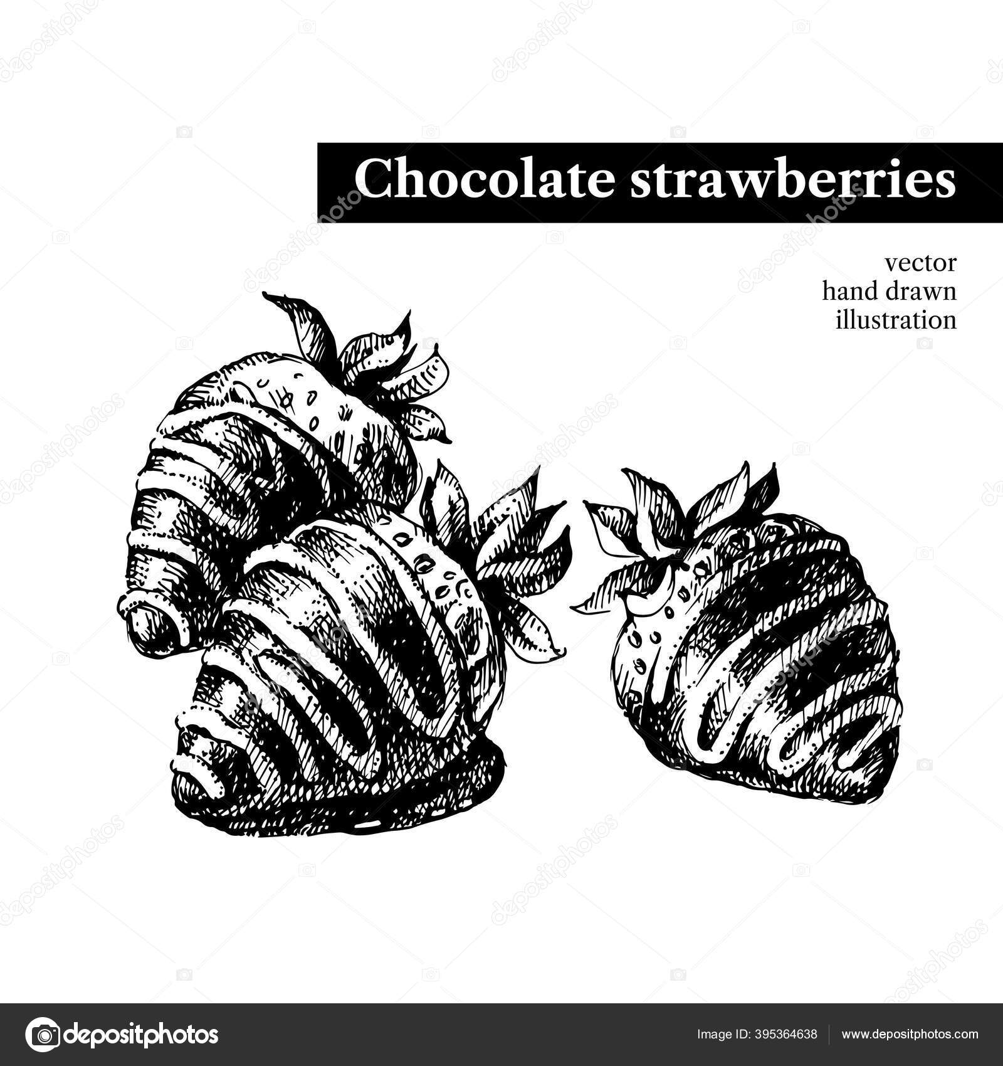
Instructions
- Start by washing the strawberries and then drying them VERY well. If the strawberries are the least bit wet the chocolate will not stick!
- Use a double boiler or microwave the chocolate for 30 second intervals, removing and stirring at each 30 second interval, until the chocolate has melted. Stir often, making sure not to burn the chocolate!
- Holding a strawberry by the stem, dip into melted chocolate, lift and twist slightly, letting the excess chocolate fall back into the bowl. Then place the strawberry on the parchment paper. Repeat with the rest of the strawberries.
- For a white chocolate drizzled strawberry, dip a fork melted white chocolate and drizzle the white chocolate over the dipped strawberries.
- Chill the strawberries until the chocolate sets, about 15 minutes.

Notes
Some people prefer to use bittersweet or semi-sweet chocolate, but milk chocolate will also work great!
Also, feel free to add toppings to your chocolate strawberries, like crushed nuts or coconut flakes. Dip them in the topping immediately after you've dipped them in the melted chocolate.

Nutrition
Calories: 40kcal | Carbohydrates: 4g | Fat: 2g | Sodium: 2mg | Potassium: 71mg | Sugar: 2g | Vitamin A: 5IU | Vitamin C: 17.8mg | Calcium: 11mg | Iron: 0.3mg

https://tastesbetterfromscratch.com/gourmet-chocolate-covered-strawberries/


MENU
FEBRUARY
2025

SENIOR DINING
More than a meal!



Meal Site Location Information To reserve your meal, call 715-373-3396

Barnes Town Hall  3360 County Hwy. N  Barnes, WI 54873 | Meal Days: Thursdays  Reservation required? Yes  Call by 9:00 a.m. the day before. | Site Opens: 11:30 a.m.  Meal Served: 12:00 noon
Bell Town Hall  22620 Ash Street  Cornucopia, WI 54827 | Meal Days: Tuesdays  Reservation required? Yes  Call by Monday at 8:30 a.m. | Site Opens: 11:30 a.m.  Meal Served: 12:00 noon
Cable United Church of Christ  13445 County Hwy. M  Cable, WI 54821 | Meal Days: 1st & 3rd Mondays of the month  Reservation required? Yes  Call by Thursday at 12:00 noon | Site Opens: 12:00 noon  Meal Served: 12:30 p.m.
Iron River Community Center  8275 E. Mill Street  Iron River, WI 54847 | Meal Days: 2nd & 4th Thurs. of the month  Reservation required? Yes  Call by Monday at noon | Site Opens: 11:30 a.m.  Meal Served: 12:00 noon
First Lutheran Church  83105 Washington Avenue  Port Wing, WI 54865 | Meal Days: Wednesdays  Reservation required? Yes  Call by Tuesday at 8:30 a.m. | Site Opens: 11:30 a.m.  Meal Served: 12:00 noon
Time Out Restaurant  4 Bayfield Street  Washburn, WI 54891 | Meal Days: Wednesdays  Reservation required? No  *Please be respectful of the restaurant and do not arrive earlier than 1:00 p.m. | Seating Opens: 1:00 PM*  Meal Served: 1:30 – 2:00 p.m.  Site Closes: 3:00 p.m.
St. Louis School  713 Washington Avenue  Washburn, WI 54891 | Meal Days: Fridays  Reservation required? Yes  Call by 3:00 p.m. Wednesday | Site Opens: 11:30 a.m.  Meal Served: 12:00 noon

Be sure to include your name, phone number, meal site location and date you are making the reservation, and how many people you are making reservations for.

Suggested contribution amount is $3.00 - $5.00 per meal. All contributions are used to fund the program.

k:\aging and disabilities\elder nutrition program\menus\current\2024 congregate\01-2024 menu february.docx

