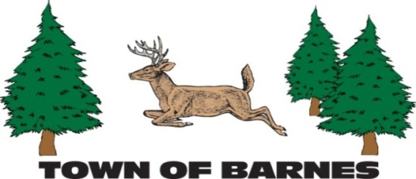

NOTICE/AGENDA

ROADS AND RIGHT OF WAY COMMITTEE MEETING

March 4, 2025

6:30PM, Town Garage

**AGENDA**

1. **Roll call, establish quorum, and verification of public notice**
2. **Approve minutes of 2/4/2025 meeting**
3. **Public comment -- 10 minute time limit enforced**
4. **Building committee**
5. **Driveway ordinance**
6. **Roads rating system**
7. **Barnstormers**
8. **New truck**
9. **Highways and Right of Way committee**
10. **Determine April meeting date**
11. **Adjourn**

Submitted by Mark Holm

mhhusker@aol.com