Senior Dining Menu – Washburn & The South Shore March 2025

Meal Reservation Line – (715) 373-3396

MONDAY | TUESDAY | WEDNESDAY |  | THURSDAY | FRIDAY
3 | 4 | 5 |  | 6 | 7
Sweet & Sour Chicken  Brown Rice  Steamed Broccoli  Banana  Dessert | Chicken Cordon Bleu  Rice Pilaf  Mix Veggies  Lettuce Salad  Peaches | Bake Pork Chop  Au Gratin Potato  Edamame Salad  Oranges  Whole Wheat  Butter Bread |  | Fish Sandwich  Brussel Sprouts  Roasted Potatoes  Pears  Whole Wheat Bread | NO MEAL
10 | 11 | 12 |  | 13 | 14
Chicken Stuffing Casserole  Lettuce Salad  Peaches  Dessert  Whole Wheat  Butter Bread | Meat Loaf  Glazed Carrots  Mash Potatoes  and Gravy  Pears  Whole Wheat Butter Bread  Cake | Salisbury Steak  Mash Potatoes  and Gravy  Corn  Peaches  Lettuce Salad  Whole Wheat  Buttered Bread |  | Teriyaki Chicken  Brown Rice  Stir Fry Veggies  Pineapple  Egg Roll | NO MEAL
17 | 18 | 19 |  | 20 | 21
Tuna Casserole  Carrots  Lettuce Salad  Dessert with Fruit  Whole Wheat  Butter Bread | Swedish Meatballs  Egg Noodles  Carrots  Oranges  Lettuce Salad  Whole Wheat Butter Bread | Chicken Cacciatore  Spinach Gnocchi  Green Beans  Peaches  Whole Wheat  Butter Bread  Cake |  | Broiled Fish  Lemon Garlic Sauce  Coleslaw  Roasted Potatoes  Applesauce  Cake  Whole Wheat  Butter Bread | NO MEAL
24 | 25 | 26 |  | 27 | 28
Cheeseburger  Lettuce, Tomato Onion  Brussels Sprouts  Jello w/Fruit Cocktail  3 Bean Salad  Whole Wheat Bun | Chicken Tetrazzini  Green Beans  Mandarin Oranges  Dessert  Whole Wheat Butter Bread | Brat Patty  Baked Beans  Au Gratin Potato  Apple Crisp  Whole Wheat Bun |  | Broccoli Cheese Soup  Egg Salad on Croissant  Mandarin Oranges | NO MEAL
31 |  |  | 
Buttermilk Biscuit Sausage Gravy
American Fries
Yogurt
Fresh Berries
Fruit Juice

NOTE: Menus are subject to change without notice.

Word Search: Superfoods
Created by: Kim White Steele for Puzzles to Print (©2022)

Z | T | U | O | R |  | P | S | S | L |  | E | S | S | U |  | R | B | K | P |  | X | X | G | L
J | E | G | A | B |  | B | A | C | T |  | S | O | P | A |  | T | D | C | I |  | E | P | G | I
P | N | A | E | B |  | K | C | A | L |  | B | T | A | I |  | L | E | N | V |  | P | T | N | R
T | U | P | T | I |  | U | R | F | E |  | P | A | R | G |  | N | M | E | D |  | U | U | S | D
X | P | E | A | D |  | D | X | U | S |  | P | M | Q | G |  | T | A | O | B |  | O | F | G | U
J | N | C | T | B |  | Q | I | U | P |  | W | O | S | D |  | Z | H | C | N |  | L | H | R | Y
G | Z | G | K | N |  | T | E | L | H |  | Y | T | T | Q |  | F | Y | B | H |  | A | F | L | X
Q | J | A | E | T |  | N | E | E | R |  | G | B | G | M |  | R | S | V | L |  | T | D | T | D
L | B | M | T | B |  | A | G | R | O |  | A | P | E | E |  | B | T | O | J |  | N | R | N | K
Q | F | K | H | D |  | R | E | J | W |  | V | Z | E | H |  | W | I | V | E |  | A | P | U | Z
S | A | L | J | Q |  | B | I | O | D |  | G | B | B | P |  | Z | E | N | K |  | C | Q | D | U
U | S | C | Z | P |  | B | V | O | Y |  | N | K | U | Q |  | T | K | V | F |  | R | E | T | A
G | R | Z | S | E |  | O | Q | K | A |  | I | L | O | C |  | C | O | R | B |  | E | B | O | B
A | H | A | R | D |  | D | W | R | K |  | K | G | T | W |  | R | H | W | S |  | T | N | N | R
R | R | R | E | C |  | A | C | J | Z |  | D | E | A | J |  | D | C | A | A |  | I | P | I | O
A | Y | H | D | H |  | C | Y | Q | T |  | D | V | L | F |  | M | I | U | U |  | Q | W | G | W
P | Z | F | A | C |  | O | B | I | N |  | K | Q | H | P |  | H | T | Q | O |  | S | Z | F | N
S | L | C | M | Y |  | V | T | O | J |  | W | G | U | C |  | G | R | K | J |  | C | Q | M | R
A | R | F | A | P |  | A | M | I | P |  | A | H | Q | N |  | V | A | A | A |  | E | T | L | I
Q | Y | X | M | F |  | L | A | X | S |  | E | E | D | S |  | T | O | Z | R |  | L | S | T | C
G | H | H | E | A |  | W | A | T | E |  | R | M | E | L |  | O | N | W | U |  | K | E | C | E
Almond  Apple  Artichoke  Asparagus  Avocado  Beet |  |  |  |  | Black Bean  Broccoli  Brown Rice  Brussels Sprout  Cabbage  Cantaloupe |  |  |  |  | Chia Seed  Cranberry  Edamame  Flax Seed  Goji Berry  Grapefruit |  |  |  |  | Green Tea  Kale  Kelp  Quinoa  Raspberry |  |  |  |  | Salmon  Spinach  Tomato  Watermelon

March 2025 TOPIC: Common Health Scams
Article courtesy of FTC Consumer Advice Part 3 of 4-part series

 | Did you know….  The first four months of this new year, we are continuing a series of articles addressing health and nutrition scams that are common in the United States. Last month, we talked about some ways companies scam people in the areas of memory loss, anti-aging products and arthritis. This month, we will talk about common scams related to cancer, chronic pain and diabetes.
Cancer
If you or someone you love has cancer, you may be tempted to try supposed cancer-fighting products — like pills, powders, and herbs — that you’ve seen advertised or heard about from family and friends. Maybe you’ve even heard about some foreign clinics offering treatments that aren’t available in the U.S. Whether you’re looking in the U.S. or abroad, know this:

- No single device, remedy, or treatment can treat all types of cancer. All cancers are different and no single treatment works for everybody, or for every cancer. Even two people with the same diagnosis may need different treatments.
- Scammers promote unproven — and potentially dangerous — substances like teas, salves, and pills containing ingredients that can be toxic. Don’t use them.
- If you or someone you know has cancer and is interested in experimental treatments, talk with your doctor about joining a clinical study. Know that taking part in a clinical trial can have both benefits and risks.

For more information about cancer treatments, visit the American Cancer Society or call the National Cancer Institute's Cancer Information Service at 1-800-4-CANCER (1-800-422-6237). To get free publications on cancer research and treatment, or to learn about clinical trials, visit cancer.gov. Decide on treatments with your doctor, who knows the science and your treatment needs.

March 2025 TOPIC: Common Health Scams
Article courtesy of FTC Consumer Advice Part 3 of 4-part series

Chronic Pain
Chronic pain has many causes, including injuries, illness, and prolonged physical or emotional stress. Some companies market products and devices by claiming they treat chronic pain throughout the body, but without the scientific evidence to back up their claims. Some also claim they’re clinically proven and cleared by the FDA, but they’re not (or they don’t work as advertised, anyway). If you or someone you know has chronic pain and is thinking about using a product or device to treat it, here are some things to do:

- Do some research and ask your doctor if a product or treatment you’re considering will work for you.
- If you get a robocall offering treatment for chronic pain, hang up. Scammers often call to ask about any chronic pain you may be struggling with and then offer to solve your problem, all to get you to hand over money or your personal information. Don’t do it.
- Check out treatment options for chronic pain and look at the evidence and results of studies at the National Institutes of Health’s (NIH) National Center of Complementary and Integrative Health.

Diabetes
Like many chronic diseases, diabetes requires individualized treatment by a physician. There isn't a cure yet for diabetes, but losing weight, eating healthy food, and being active can help. Taking medicine as needed, getting diabetes self-management education and support, and keeping health care appointments can also help lessen the impact of diabetes on your life. If you or someone you know is thinking about using a nonprescription product to treat diabetes:

- Remember that supplements can be dangerous — especially if they cause you to delay or stop effective, proven treatments for diabetes.
- Talk with your health care provider first. If you’re tempted to use a nonprescription product to treat diabetes, high blood sugar, or any other serious health condition, talk with your health care provider before you act.

For more information about diabetes treatments, visit The Centers for Disease Control and Prevention and The American
Diabetes Association.

Source: https://consumer.ftc.gov/articles/common-health-scams

March 2025 Vegetables: Spinach

Author: https://www.skinnykitchen.com/recipes/eat-your-spinach-that-is-garlic-sauteed-spinach/#recipe

Super Healthy, Garlic Sautéed Spinach
A delicious, quick and easy go-to recipe, a delicious side dish or addition to pastas, eggs, grain bowls, and more.

Ingredients  2 teaspoons olive oil  1 tablespoon garlic, minced (about 3 cloves)  1 (12 oz.) bag baby spinach leaves  ¼ teaspoon salt, or to taste  Fresh ground pepper, to taste  Fresh lemon |  | 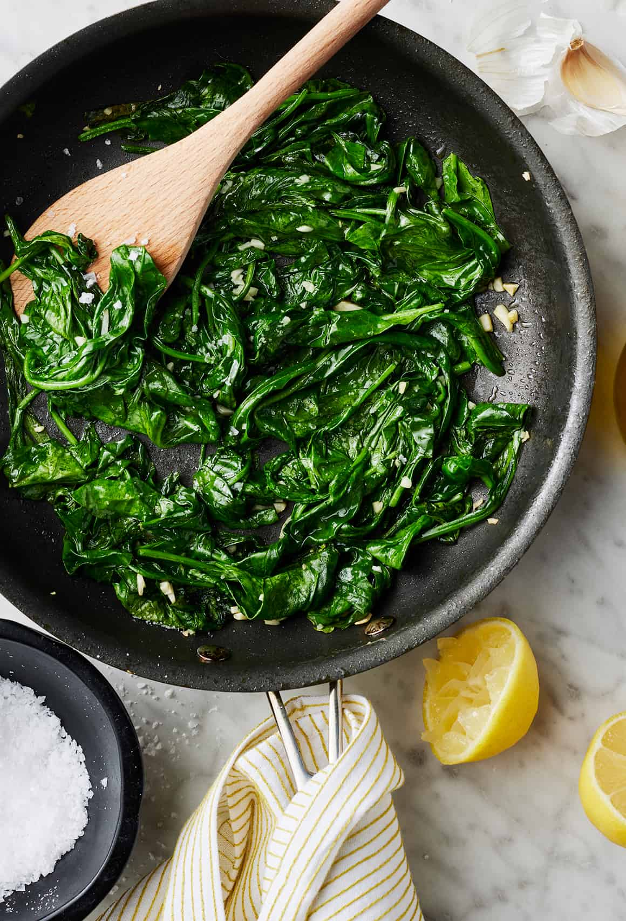
Instructions
- In a large, deep, nonstick pan or pot, heat olive oil.
- Add garlic and sauté for 1 minute.
- Add all spinach salt, pepper and toss with garlic and olive oil.
- Cover pan and cook on low for about 1 minute.
- Uncover pan, turn the heat on high and cook spinach for another minute or two, stirring with a wooden spoon until all the spinach is wilted.
- Using a slotted spoon, lift the spinach into a serving dish or bowl and squeeze with a little fresh lemon juice all over the spinach.
Serve hot.

Serving: 3 ounces = 41 calories, 4 g carbohydrates, 2g protein, and 3g fat


MENU
MARCH
2025

SENIOR DINING
More than a meal!



Meal Site Location Information To reserve your meal, call 715-373-3396

Barnes Town Hall  3360 County Hwy. N  Barnes, WI 54873 | Meal Days: Thursdays  Reservation required? Yes  Call by 9:00 a.m. the day before. | Site Opens: 11:30 a.m.  Meal Served: 12:00 noon
Bell Town Hall  22620 Ash Street  Cornucopia, WI 54827 | Meal Days: Tuesdays  Reservation required? Yes  Call by Monday at 8:30 a.m. | Site Opens: 11:30 a.m.  Meal Served: 12:00 noon
Cable United Church of Christ  13445 County Hwy. M  Cable, WI 54821 | Meal Days: 1st & 3rd Mondays of the month  Reservation required? Yes  Call by Thursday at 12:00 noon | Site Opens: 12:00 noon  Meal Served: 12:30 p.m.
Iron River Community Center  8275 E. Mill Street  Iron River, WI 54847 | Meal Days: 2nd & 4th Thurs. of the month  Reservation required? Yes  Call by Monday at noon | Site Opens: 11:30 a.m.  Meal Served: 12:00 noon
First Lutheran Church  83105 Washington Avenue  Port Wing, WI 54865 | Meal Days: Wednesdays  Reservation required? Yes  Call by Tuesday at 8:30 a.m. | Site Opens: 11:30 a.m.  Meal Served: 12:00 noon
Time Out Restaurant  4 Bayfield Street  Washburn, WI 54891 | Meal Days: Wednesdays  Reservation required? No  *Please be respectful of the restaurant and do not arrive earlier than 1:00 p.m. | Seating Opens: 1:00 PM*  Meal Served: 1:30 – 2:00 p.m.  Site Closes: 3:00 p.m.
St. Louis School  713 Washington Avenue  Washburn, WI 54891 | Meal Days: Fridays  Reservation required? Yes  Call by 3:00 p.m. Wednesday | Site Opens: 11:30 a.m.  Meal Served: 12:00 noon

Be sure to include your name, phone number, meal site location and date you are making the reservation, and how many people you are making reservations for.

Suggested contribution amount is $3.00 - $5.00 per meal. All contributions are used to fund the program.

